**LAB # 02**

**“ IMPLEMENTATION OF ACTIVATION FUNCTIONS ”**

* **OBJECTIVE:**

• Implementation of Activation Functions.

* **LAB TASKS:**

**TASK 1: Step Function**

**Goal:** Implement a step function that outputs 1 if input ≥ 0, else 0.

• Input Values: [-3.0, -1.0, 0.0, 2.0, 5.0]

• Expected Output: [0, 0, 1, 1, 1]

• Visualization: Plot the step function for inputs between -5 to 5.

* **CODE:**

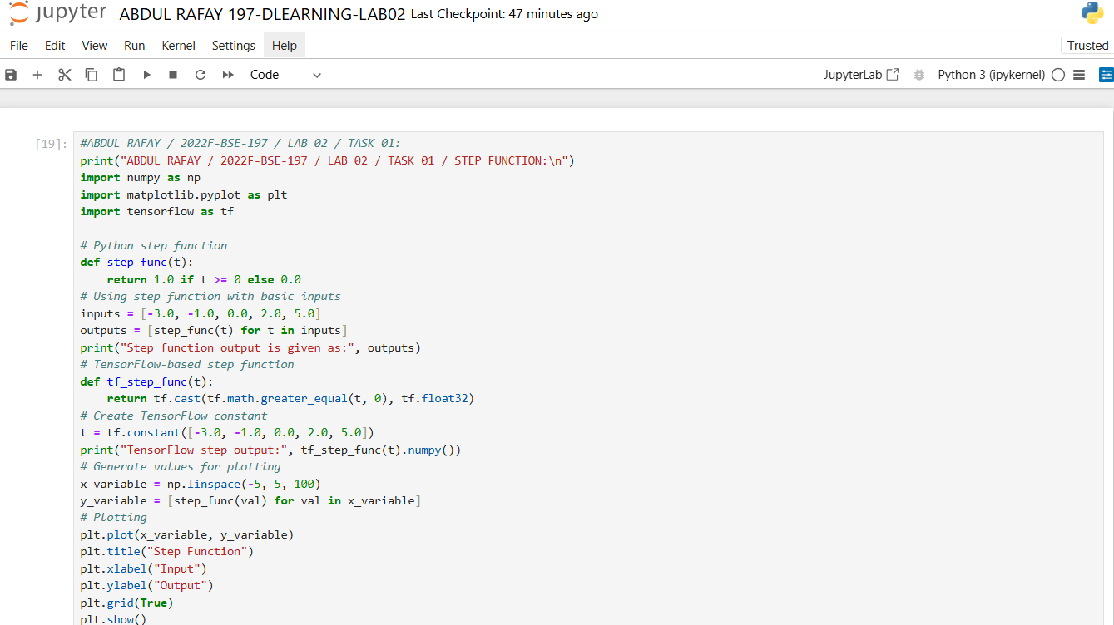

* **OUTPUT:**

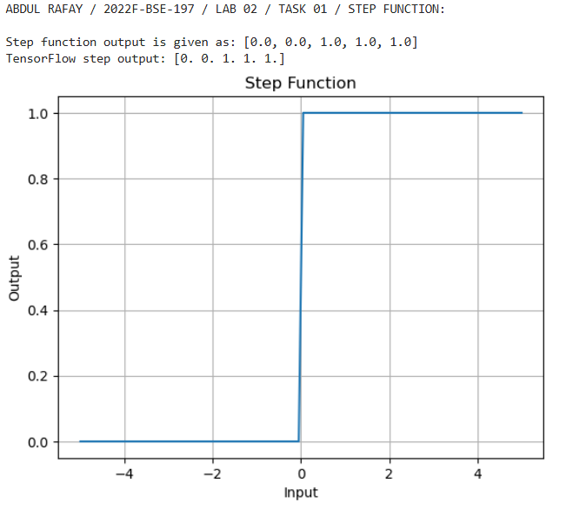

**TASK 2: ReLU (Rectified Linear Unit)**

**Goal:** Implement ReLU: f(x) = max(0, x).

• Input Values: [-4.0, -2.0, 0.0, 3.0, 5.0]

• Expected Output: [0, 0, 0, 3, 5]

• Visualization: Plot ReLU for inputs between -5 to 5.

* **CODE:**

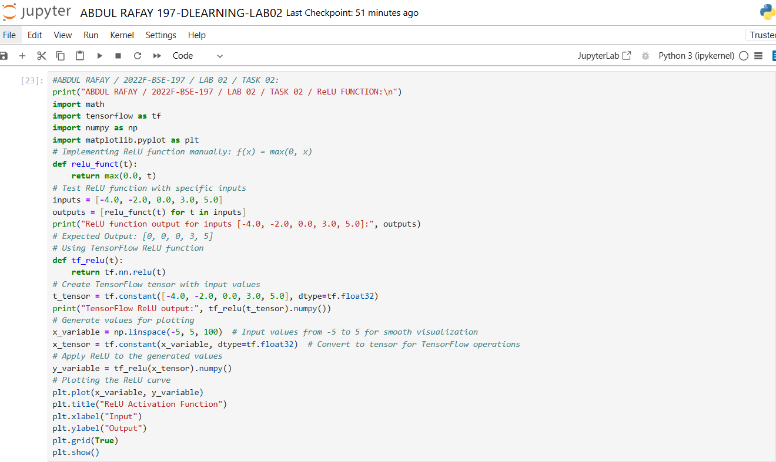

* **OUTPUT:**

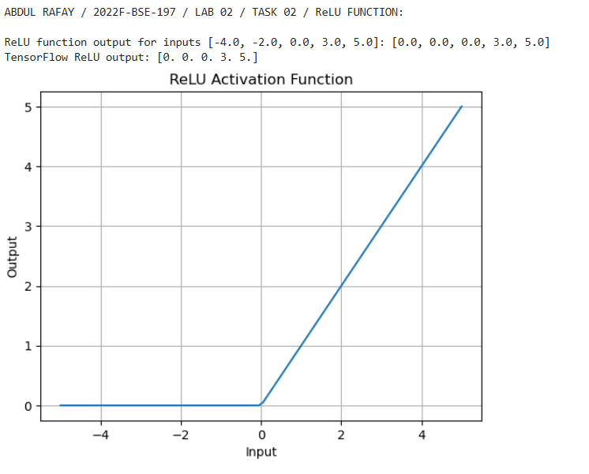

**TASK 3:** **Sigmoid**

Goal: Implement Sigmoid: f(x) = 1 / (1 + e^{-x}).

• Input Values: [-2.0, 0.0, 1.0, 3.0]

• Expected Output: ≈ [0.119, 0.5, 0.731, 0.953]

• Visualization: Plot the sigmoid curve and explain why it squashes outputs to (0,

1).

* **CODE:**

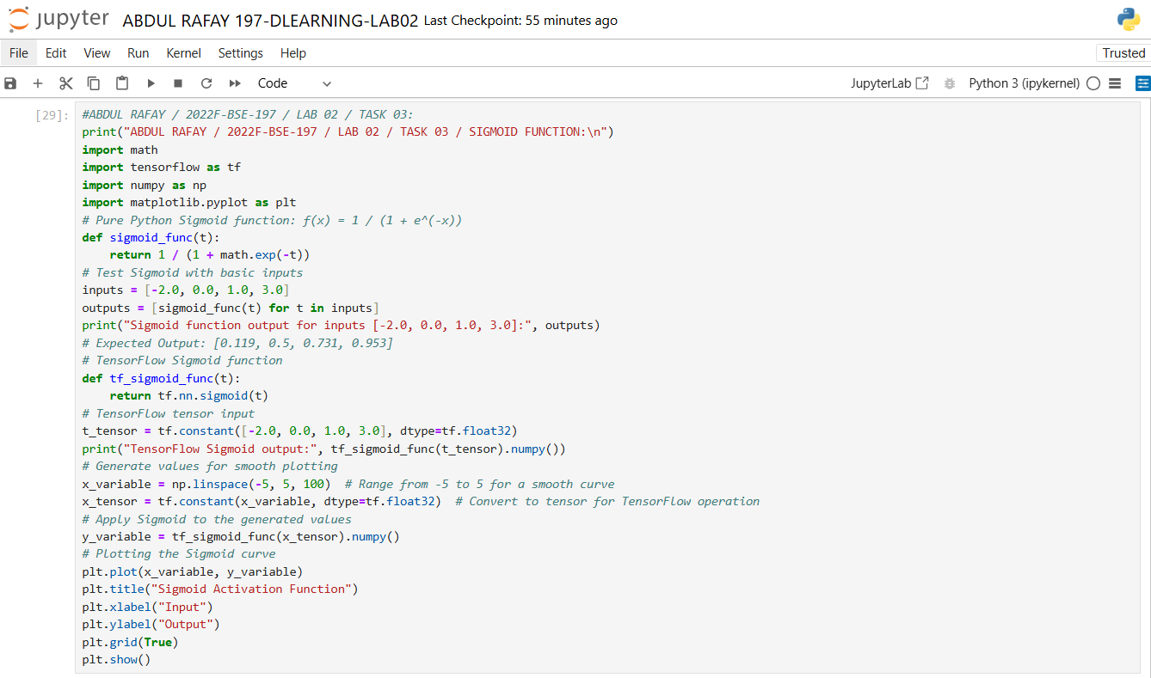

* **OUTPUT:**

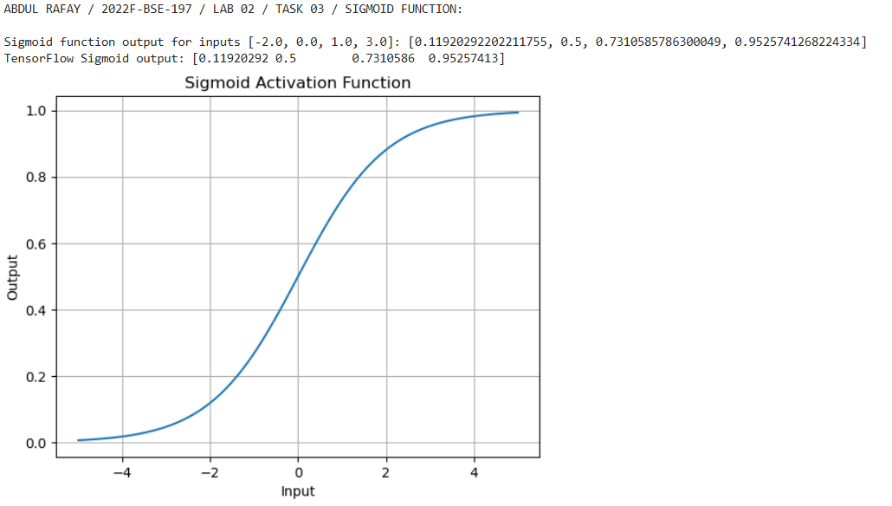

**TASK 4:** **Tanh (Hyperbolic Tangent)**

**Goal:** Implement Tanh: f(x) = (e^x - e^{-x}) / (e^x + e^{-x}).

• Input Values: [-1.5, 0.0, 1.0, 2.0]

• Expected Output: ≈ [-0.905, 0.0, 0.762, 0.964]

• Visualization: Plot Tanh and compare its range (-1, 1) to Sigmoid.

* **CODE:**

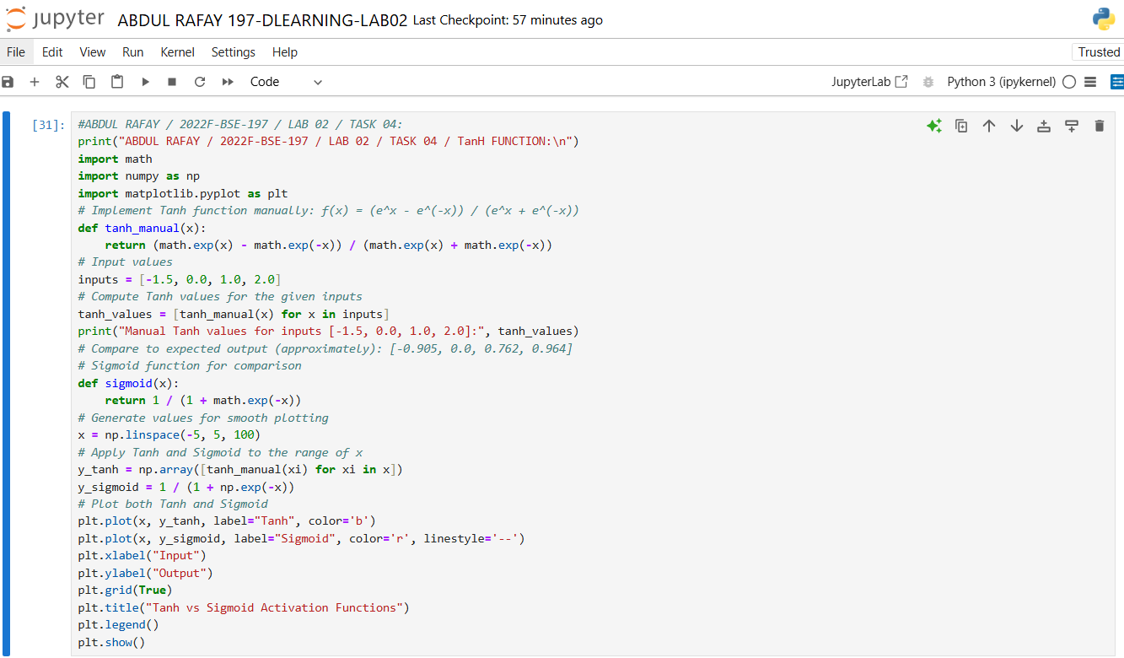

* **OUTPUT:**

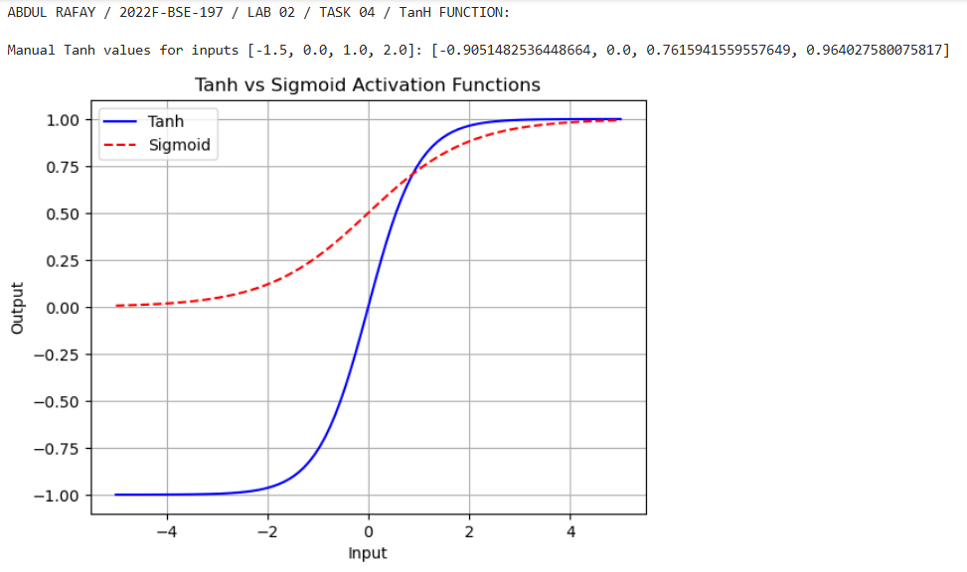

**TASK 5:** **Leaky ReLU**

**Goal:** Implement Leaky ReLU: f(x) = x if x ≥ 0 else α*x.

• Input Values: [-3.0, -1.0, 0.0, 2.0]

• Test with α = 0.1: Expected Output → [-0.3, -0.1, 0.0, 2.0]

• Visualization: Plot Leaky ReLU for α = 0.1 and α = 0.3**.**

* **CODE:**

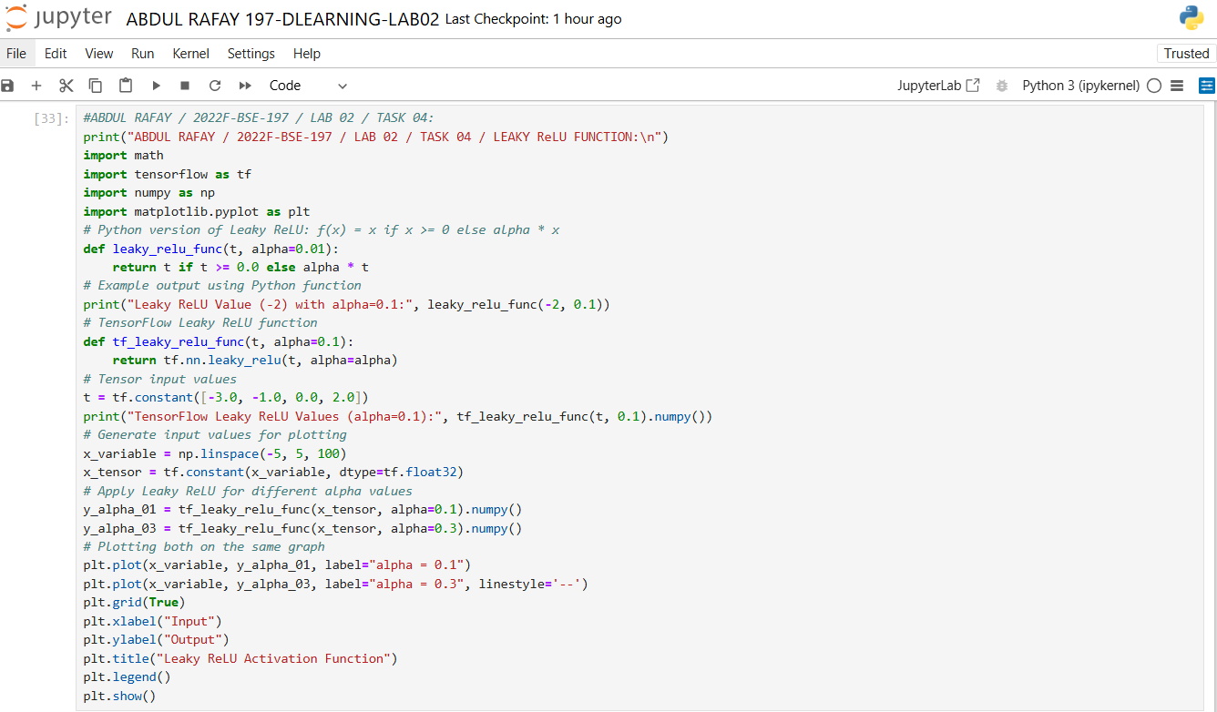

* **OUTPUT:**

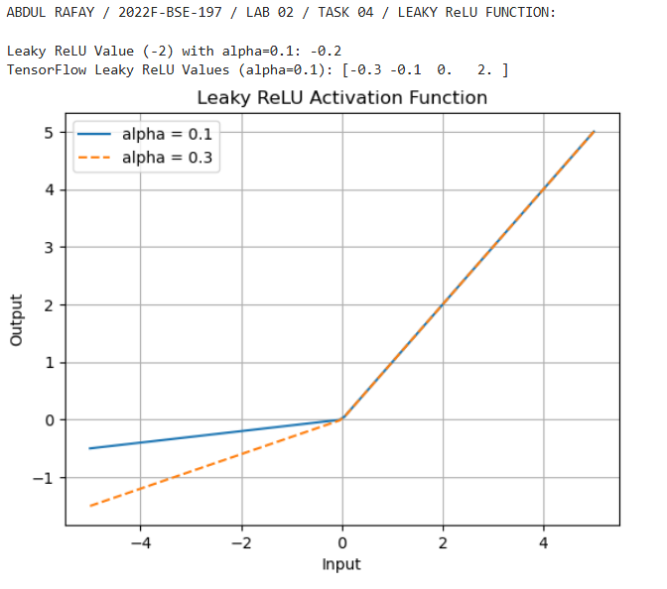

**TASK 6:** **Softmax**

**Goal:** Implement Softmax to convert inputs into probabilities.

• Input Values: [1.0, 2.0, 3.0]

• Expected Output: ≈ [0.090, 0.245, 0.665]

• Explanation: Why Softmax outputs sum to 1.0.

* **CODE:**

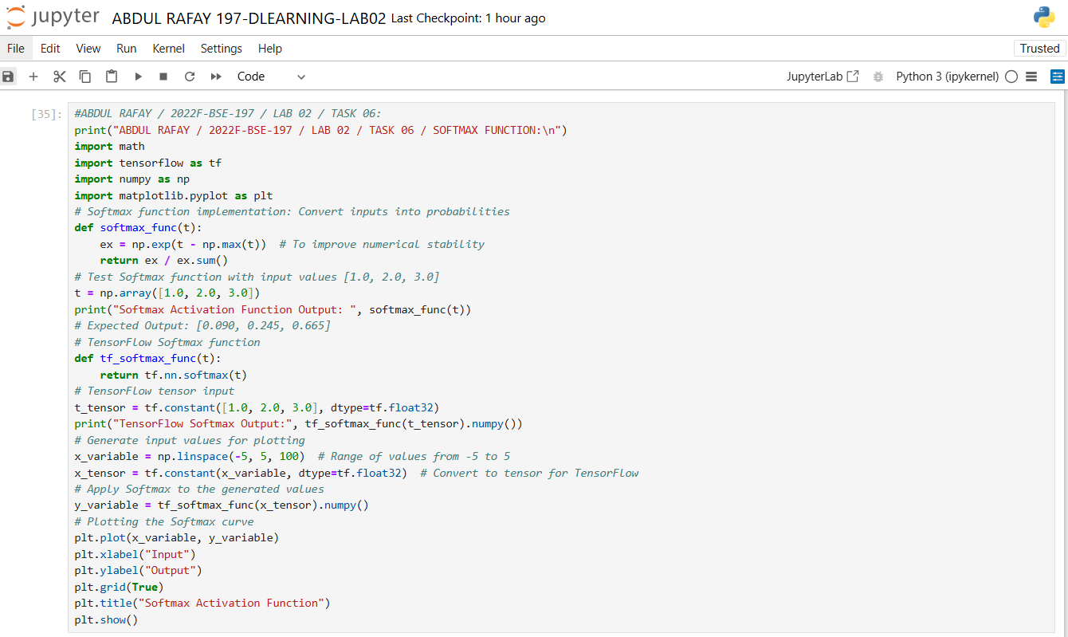

* **OUTPUT:**

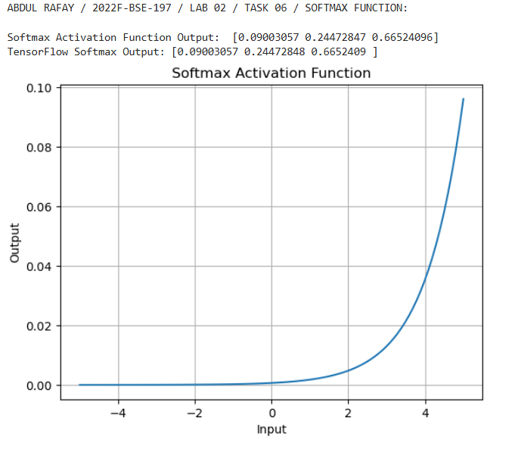

* **GITHUB UPLOAD:**
* **KAGGLE UPLOAD:**